Eleanor Roosevelt Track & Field
2016 Competition Gear Order Catalog
*Uniforms subject to change depending on availability*

Sprint/Hurdles/Relays Competition Uniforms
Girls Top Girls Bottoms Boys Compression Top Boys Bottoms
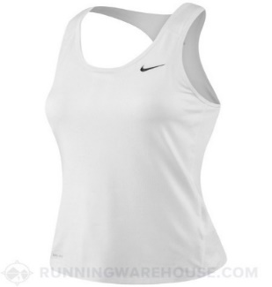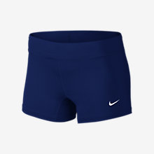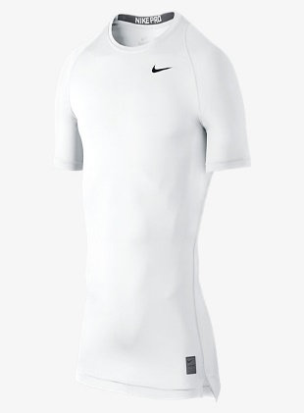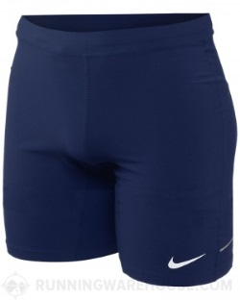

Distance/Field Competition Uniforms
Girls Top Girls Bottoms Boys Top Boys Bottoms Boys Throws Shorts
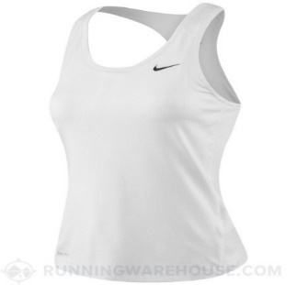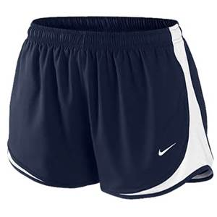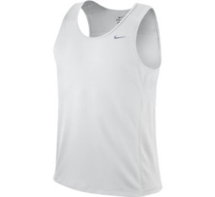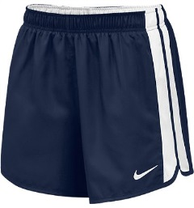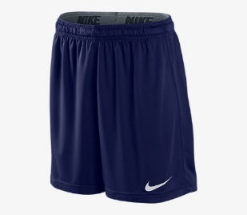

Team Warm Up Uniform

Team WU Jacket Boys WU Pant Girls WU Pants
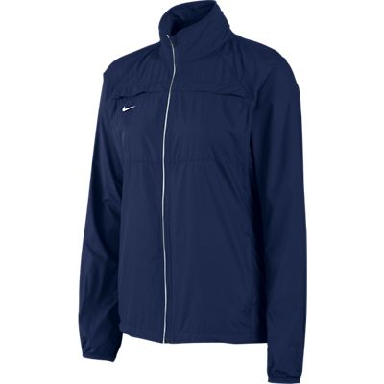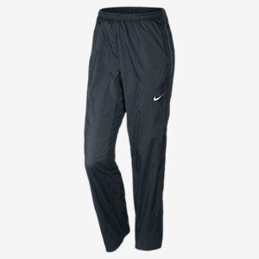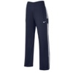

Eleanor Roosevelt Track & Field
2016 Competition Gear Order Form
Please Place Order ON January 19, 2016
Please mark the items you would like to purchase. Athletes may purchase all items however it is not necessary. If you are not able to purchase a competition uniform one will be checked out to you, Please contact Coach Shonna ASAP.

Sprints Competition Uniform ($70) - sizes run big
Top – Women S____ M____ L____ XL ____
Shorts – Women S____ M____ L____ XL_____

Top – Men S____ M____ L____ XL _____
Shorts – Men S____ M____ L____ XL _____
Distance/Field Competition Uniform ($70) – sizes run big
Top – Women S____ M____ L____ XL ____
Shorts – Women S____ M____ L____ XL_____

Top – Men S____ M____ L____ XL _____
Shorts – Men S____ M____ L____ XL _____
Shorts – Throws S ____ M ____ L ____ XL _____
Team Warm-Ups ($85) – sizes run big
Team Jacket -Women S ____ M____ L _____ XL _____
Pant – Women S ____ M ____ L _____ XL _____

Team Jacket –Men S_____M____L______XL______
Pant – Men S ____ M ____ L _____ XL _____

Please pay for your order at the ERHS ASB office STARTING JANUARY 19, 2016,
ASB does not accept checks or credit cards.
ALL UNIFORM ORDERS NEED TO BE TURNED IN TO COACH SHONNA NO LATER THAN JANUARY 21, 2016

